RAJALAKSHMI ENGINEERING COLLEGE

# RAJALAKSHMI NAGAR,THANDALAM–602105

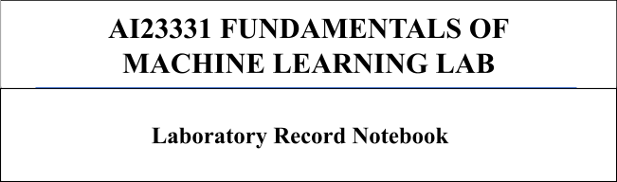

NAME: LOKAA.V

ROLL NO.: 2116231501085

CLASS & SEC: AIML-B

SEMESTER: 3

YEAR: 2024-25

**INDEX PAGE**

|  |  |  |
| --- | --- | --- |
| SL.NO | DATE | NAMEOFTHEEXPERIMENT |
| 01 | 23.08.2024 | A PYTHON PROGRAM TO IMPLEMENT UNIVARIATE REGRESSION,BIVARIATE REGRESSION AND MULTIVARIATE REGRESSION. |
| 02 | 30.08.2024 | A PYTHON PROGRAM TO IMPLEMENT SIMPLE LINEAR REGRESSION USING LEAST SQUARE METHOD |
| 03 | 06.09.2024 | A PYTHON PROGRAM TO IMPLEMENT LOGISTIC MODEL |
| 04 | 13.09.2024 | A PYTHON PROGRAM TO IMPLEMENT SINGLE LAYER PERCEPTRON |
| 05 | 20.09.2024 | A PYTHON PROGRAM TO IMPLEMENT MULTILAYER PERCEPTRON WITH BACKPROPAGATION |
| 06 | 27.09.2024 | A PYTHON PROGRAM TO DO FACE RECOGNITION USING SVM CLASSIFIER |
| 07 | 04.10.2024 | A PYTHON PROGRAM TO IMPLEMENT DECISIONTREE |
| 08 | 18.10.2024 | A PYTHON PROGRAM TO IMPLEMENT DECISION TREE |
| 09A | 25.10.2024 | A PYTHON PROGRAM TO IMPLEMENT KNN MODEL. |
| 09B | 25.10.2024 | A PYTHON PROGRAM TO IMPLEMENT K-MEANS MODEL |
| 10 | 04.11.2024 | A PYTHON PROGRAM TO IMPLEMENT DIMENSIONALITY REDUCTION -PCA. |

**EXPT NO: 1 Apythonprogramtoimplementunivariateregression DATE: 23.08.2024 bivariate regression and multivariate regression.**

# AIM:

Towriteapythonprogramtoimplementunivariateregression,bivariate regression and multivariate regression.

# PROCEDURE:

Implementingunivariate,bivariate,andmultivariateregressionusingtheIris dataset involve the following steps:

**Step1:ImportNecessaryLibraries**

First,importthelibrariesthatareessentialfordatamanipulation,visualization,and model building.

import numpy as np importpandasaspd

import seaborn as sns

import matplotlib.pyplot as plt

fromsklearn.model_selectionimporttrain_test_split from sklearn.linear_model import LinearRegression

from sklearn.metrics import mean_squared_error, r2_score

**Step2:LoadtheIrisDataset**

TheIrisdatasetcanbeloadedanddisplaythefirstfewrowsofthedataset.

3 231501082

# Load the Iris dataset

iris = sns.load_dataset('iris')

# Display the first few rows of the dataset

print(iris.head())

# OUTPUT:

**Step3:DataPreprocessing**

Ensurethedataiscleanandreadyformodeling.SincetheIrisdatasetisclean, minimal preprocessing is needed.

#Checkformissingvalues print(iris.isnull().sum())

#Displaythebasicstatisticaldetails print(iris.describe())

# OUTPUT:

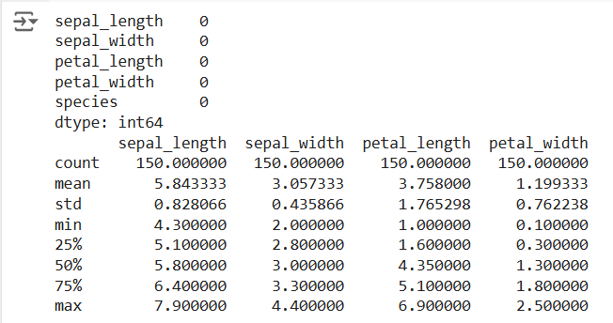

**Step4:UnivariateRegression**

Univariateregressioninvolvespredictingonevariablebasedonasinglepredictor.

* 1. **:SelecttheFeatures**

Chooseonefeature(e.g.,sepal_length)andonetargetvariable(e.g.,sepal_width).

X_uni=iris[['sepal_length']] y_uni = iris['sepal_width']

* 1. **:SplittheData**

Splitthedataintotrainingandtestingsets.

Fitthelinearregressionmodelonthetrainingdata.

X_uni_train,X_uni_test,y_uni_train,y_uni_test=train_test_split(X_uni, y_uni,

test_size=0.2, random_state=42)

* 1. **:Trainthemodel**

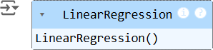

uni_model = LinearRegression() uni_model.fit(X_uni_train,y_uni_train)

* 1. **:Make Predictions**

Usethemodeltomakepredictionsonthetestdata.

y_uni_pred = uni_model.predict(X_uni_test)

* 1. **:EvaluatetheModel**

EvaluatethemodelperformanceusingmetricslikeMeanSquaredError(MSE) and R-squared.

print(f'UnivariateMSE:{mean_squared_error(y_uni_test,y_uni_pred)}') print(f'Univariate R-squared: {r2_score(y_uni_test, y_uni_pred)}')

# OUTPUT:

* 1. **:VisualizetheResults**

Visualizetherelationshipbetweenthepredictorandthetargetvariable.

plt.scatter(X_uni_test,y_uni_test,color='blue') plt.plot(X_uni_test, y_uni_pred, color='red') plt.xlabel('Sepal Length')

plt.ylabel('Sepal Width') plt.title('UnivariateRegression') plt.show()

# OUTPUT:

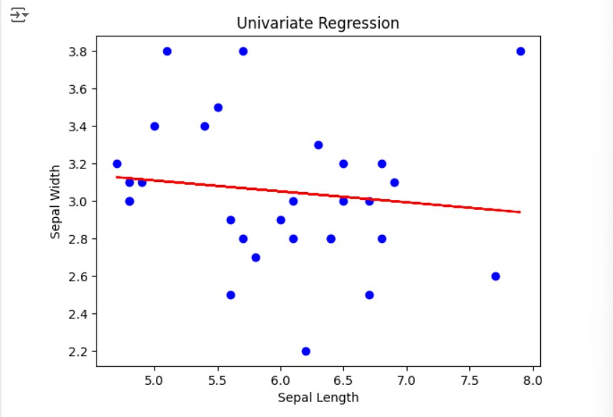

**Step5:BivariateRegression**

Bivariateregressioninvolvespredictingonevariablebasedontwopredictors.

* 1. **:SelecttheFeatures**

Choosetwofeatures(e.g.,sepal_length,petal_length)andonetargetvariable(e.g., sepal_width).

X_bi = iris[['sepal_length', 'petal_length']]

y_bi= iris['sepal_width']

* 1. **:SplittheData**

Splitthedataintotrainingandtestingsets.

X_bi_train, X_bi_test, y_bi_train, y_bi_test = train_test_split(X_bi, y_bi,

test_size=0.2, random_state=42)

* 1. **:TraintheModel**

Fitthelinearregressionmodelonthetrainingdata.

bi_model = LinearRegression()

bi_model.fit(X_bi_train, y_bi_train)

# OUTPUT:

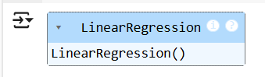

* 1. **:Make Predictions**

Usethemodeltomakepredictionsonthetestdata.

y_bi_pred = bi_model.predict(X_bi_test)

* 1. **:EvaluatetheModel**

EvaluatethemodelperformanceusingmetricslikeMSEandR-squared.

print(f'BivariateMSE:{mean_squared_error(y_bi_test,y_bi_pred)}') print(f'Bivariate R-squared: {r2_score(y_bi_test, y_bi_pred)}')

OUTPUT:



* 1. **:VisualizetheResults**

Sincevisualizingin3Dischallenging,wecanplottherelationshipsbetweenthe target and each predictor separately.

#SepalLengthvsSepalWidth plt.subplot(1, 2, 1)

plt.scatter(X_bi_test['sepal_length'],y_bi_test,color='blue') plt.plot(X_bi_test['sepal_length'], y_bi_pred, color='red') plt.xlabel('Sepal Length')

plt.ylabel('Sepal Width')

#PetalLengthvsSepalWidth plt.subplot(1, 2, 2)

plt.scatter(X_bi_test['petal_length'],y_bi_test,color='blue') plt.plot(X_bi_test['petal_length'], y_bi_pred, color='red') plt.xlabel('Petal Length')

plt.ylabel('Sepal Width')

plt.suptitle('BivariateRegression') plt.show()

# OUTPUT:

**Step6:MultivariateRegression**

Multivariateregressioninvolvespredictingonevariablebasedonmultiple predictors.

* 1. **:SelecttheFeatures**

Choosemultiplefeatures(e.g.,sepal_length,petal_length,petal_width)andone target variable (e.g., sepal_width).

X_multi = iris[['sepal_length', 'petal_length', 'petal_width']]

y_multi= iris['sepal_width']

* 1. **:SplittheData**

Splitthedataintotrainingandtestingsets.

X_multi_train,X_multi_test,y_multi_train,y_multi_test= train_test_split(X_multi,

y_multi, test_size=0.2, random_state=42)

* 1. **:TraintheModel**

Fitthelinearregressionmodelonthetrainingdata.

multi_model = LinearRegression() multi_model.fit(X_multi_train,y_multi_train)

# OUTPUT:

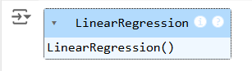

* 1. **:Make Predictions**

Usethemodeltomakepredictionsonthetestdata.

y_multi_pred = multi_model.predict(X_multi_test)

* 1. **:EvaluatetheModel**

EvaluatethemodelperformanceusingmetricslikeMSEandR-squared.

print(f'MultivariateMSE:{mean_squared_error(y_multi_test,y_multi_pred)}') print(f'Multivariate R-squared: {r2_score(y_multi_test, y_multi_pred)}')

# OUTPUT:

**Step7:Visualizethemultivariateregression**

plt.figure(figsize=(15,4)) plt.subplot(1, 2, 1)

plt.scatter(X_multi_test['sepal_length'],y_multi_test,color='blue') plt.plot(X_multi_test['sepal_length'], y_multi_pred, color='red') plt.xlabel('sepal_length')

plt.ylabel('sepal_width')

plt.title('MultivariateRegression-1') plt.show()

plt.figure(figsize=(15,4)) plt.subplot(1, 2, 1)

plt.scatter(X_multi_test['petal_length'],y_multi_test,color='blue') plt.plot(X_multi_test['petal_length'], y_multi_pred, color='red') plt.xlabel('petal_length')

plt.ylabel('sepal_width')

plt.title('MultivariateRegression-2') plt.show()

plt.figure(figsize=(15,4)) plt.subplot(1, 2, 2 )

plt.scatter(X_multi_test['petal_length'],y_multi_test,color='blue') plt.plot(X_multi_test['petal_length'], y_multi_pred, color='red') plt.xlabel('petal_length')

plt.ylabel('sepal_width')

plt.title('MultivariateRegression-3') plt.show()

# OUTPUT:

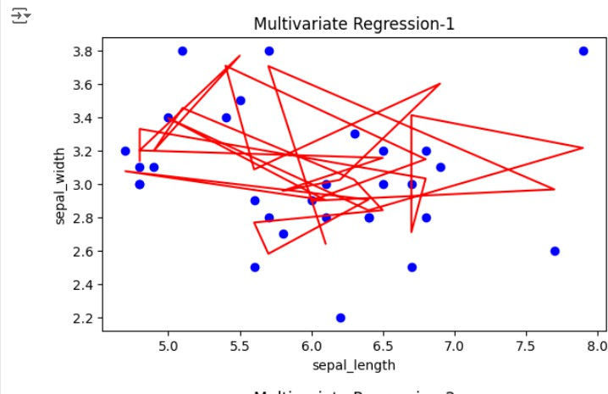

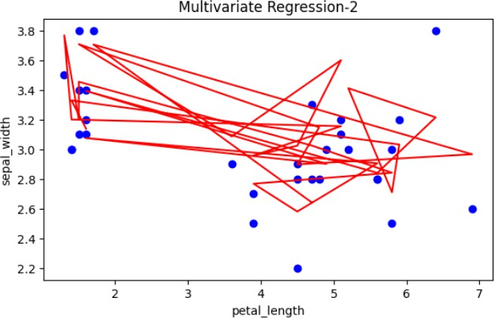

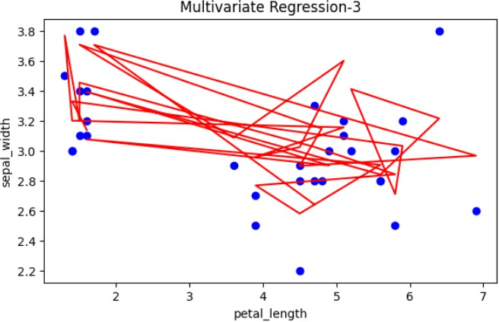

**Step8:InterprettheResults**

Afterimplementingandevaluatingthemodels,interpretthecoefficientsto understand the influence of each predictor on the target variable.

print('UnivariateCoefficients:',uni_model.coef_) print('Bivariate Coefficients:', bi_model.coef_)

print('Multivariate Coefficients:', multi_model.coef_)

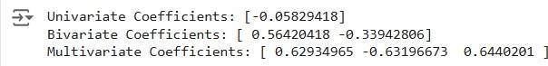**OUTPUT :**

# RESULT:

This step-by-step process will help us to implement univariate, bivariate, and multivariateregressionmodelsusingtheIrisdatasetandanalyzetheirperformance.

**EXPT NO : 2 ApythonprogramtoimplementSimplelinear DATE: 30.08.2024 Regression using Least Square Method**

# AIM:

TowriteapythonprogramtoimplementSimplelinearregressionusingLeast Square Method.

# PROCEDURE:

ImplementingSimplelinearregressionusingLeastSquaremethodusingthe headbrain dataset involve the following steps:

**Step1:ImportNecessaryLibraries**

First,importthelibrariesthatareessentialfordatamanipulation,visualization,and model building.

import pandas as pd

importmatplotlib.pyplotasplt import numpy as np

**Step2:LoadtheIrisDataset**

TheHeadBraindatasetcanbeloaded.

data= pd.read_csv('/content/headbrain.csv')

**Step3:DataPreprocessing**

Ensurethedataiscleanandreadyformodeling.SincetheIrisdatasetisclean, minimal preprocessing is needed.

x,y=np.array(list(data['HeadSize(cm^3)'])),np.array(list(data['Brain Weight(grams)']))

print(x[:5],y[:5])

# OUTPUT:



**Step4:ComputetheLeastSquaresSolution**

Applytheleastsquaresformulatofindtheregressioncoefficients.

def get_line(x,y):

x_m,y_m=np.mean(x),np.mean(y) print(x_m,y_m)

x_d,y_d=x-x_m,y-y_m

m=np.sum(x_d*y_d)/np.sum(x_d**2) c = y_m - (m*x_m)

print(m, c)

returnlambdax:m*x+c lin=get_line(x,y)

# OUTPUT:



**Step5:Make Predictions**

Usethemodeltomakepredictionsbasedontheindependentvariable.

def get_error(line_fuc, x, y):

y_m = np.mean(y)

y_pred=np.array([line_fuc(_)for_inx]) ss_t = np.sum((y-y_m)**2)

ss_r=np.sum((y-y_pred)**2) return 1-(ss_r/ss_t)

get_error(lin, x, y)

fromsklearn.linear_modelimportLinearRegression x = x.reshape((len(x),1))

reg=LinearRegression() reg=reg.fit(x, y)

print(reg.score(x, y))

# OUTPUT:





**Step6:VisualizetheResults**

Plottheoriginaldatapointsandthefittedregressionline.

x=np.linspace(np.min(x)-100,np.max(x)+100,1000) y=np.array([lin(x)for x in x])

plt.plot(x, y, color='red', label='Regression line') plt.scatter(x,y,color='green',label='Scatterplot') plt.xlabel('Head Size(cm^3)')

plt.ylabel('BrainWeight(grams)') plt.legend()

plt.show()

# OUTPUT:

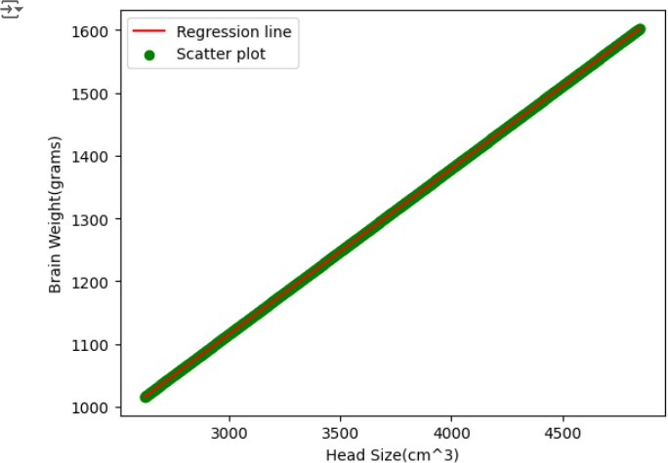

**RESULT:**

Thisstep-by-stepprocesswillhelpustoimplementleastsquareregressionmodels using the HeadBrain dataset and analyze their performance.

**EXPT NO : 3 ApythonprogramtoimplementLogisticModel DATE: 06.09.2024**

# AIM:

TowriteapythonprogramtoimplementaLogisticModel.

**PROCEDURE:**

ImplementingLogisticmethodusingtheirisdatasetinvolvethefollowingsteps:

**Step1:ImportNecessaryLibraries**

First,importthelibrariesthatareessentialfordatamanipulation,visualization,and model building.

#Step1:ImportNecessaryLibraries import numpy as np

import pandas as pd

import matplotlib.pyplot as plt

fromsklearn.model_selectionimporttrain_test_split from sklearn.linear_model import LogisticRegression

fromsklearn.metricsimportaccuracy_score,confusion_matrix, classification_report

**Step2:LoadtheIrisDataset**

Theirisdatasetcanbeloaded.

# Step 2: Load the Dataset

#Forthisexample,we'lluseabuilt-indatasetfromsklearn.Youcan replace it with your dataset.

from sklearn.datasets import load_iris

#Loadtheirisdataset data = load_iris()

X = data.data

y = (data.target == 0).astype(int) #Forbinaryclassification(classifying Iris-setosa)

**Step3:DataPreprocessing**

Ensurethedataiscleanandreadyformodeling.SincetheIrisdatasetisclean, minimal preprocessing is needed.

# Step 3: Prepare the Data

# Split the dataset into training and testing sets

X_train,X_test,y_train,y_test=train_test_split(X,y,test_size=0.2, random_state=42)

**Step4:TrainaModel**

# Step 4: Create and Train the Model

model=LogisticRegression() model.fit(X_train, y_train)

# OUTPUT:

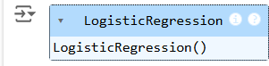

**Step5:Make Predictions**

Usethemodeltomakepredictionsbasedontheindependentvariable.

# Step 5: Make Predictions

y_pred = model.predict(X_test)

**Step6:EvaluatetheModel**

Evaluatethemodelperformance.

# Step 6: Evaluate the Model

accuracy = accuracy_score(y_test, y_pred) conf_matrix = confusion_matrix(y_test, y_pred) class_report=classification_report(y_test,y_pred) # Print evaluation metrics

print(f"Accuracy:{accuracy}") print("Confusion Matrix:")

print(conf_matrix)

print("ClassificationReport:") print(class_report)

# OUTPUT:

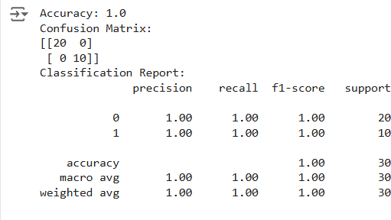

**Step7:VisualizetheResults**

Plottheoriginaldatapointsandthefittedregressionline.

# Step 7: Visualize Results (Optional)

x_values = np.linspace(-10, 10, 100)

sigmoid_values = 1 / (1 + np.exp(-x_values))

#Plotthesigmoidfunction plt.figure(figsize=(10, 5))

plt.plot(x_values,sigmoid_values,label='SigmoidFunction',color='blue') plt.title('Sigmoid Function')

plt.xlabel('x')

plt.ylabel('σ(x)') plt.grid()

plt.axhline(0.5, color='red', linestyle='--') #Lineaty=0.5 plt.axvline(0, color='gray', linestyle='--') # Line at x=0 plt.legend()

plt.show()

# OUTPUT:

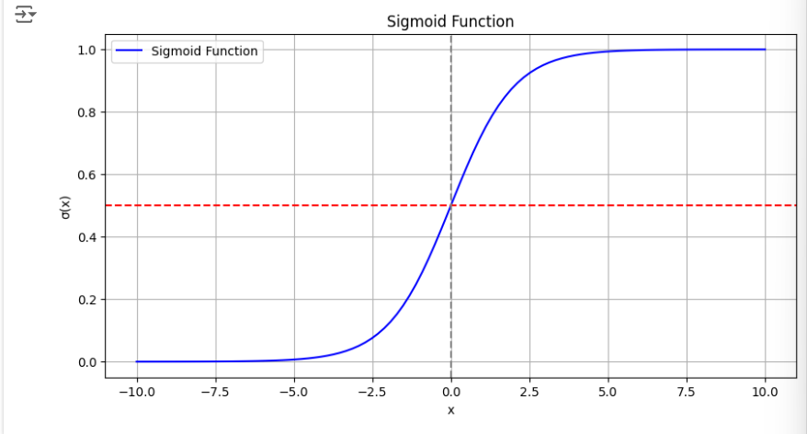

**RESULT:**

Thisstep-by-stepprocesswillhelpustoimplementLogisticmodelsusingtheIris dataset and analyze their performance.

**EXPT NO : 4 ApythonprogramtoimplementSingleLayer DATE: 13.09.2024 Perceptron**

# AIM:

TowriteapythonprogramtoimplementSinglelayerperceptron.

# PROCEDURE:

ImplementingSinglelayerperceptronmethodusingtheKerasdatasetinvolvethe following steps:

**Step1:ImportNecessaryLibraries**

First,importthelibrariesthatareessentialfordatamanipulation,visualization,and model building.

import numpy as np importpandasaspd

from tensorflow import keras

import matplotlib.pyplot as plt

**Step2:LoadtheKerasDataset**

TheKerasdatasetcanbeloaded.

(X_train,y_train),(X_test,y_test)=keras.datasets.mnist.load_data()

**Step3:DataPreprocessing**

Ensurethedataiscleanandreadyformodeling.SincetheIrisdatasetisclean, minimal preprocessing is needed.

print(f"Trainingset:{X_train.shape}") print(f"Testing set:{X_test.shape}")

print(X_train[1].shape)

plt.matshow(X_train[1])

# OUTPUT:

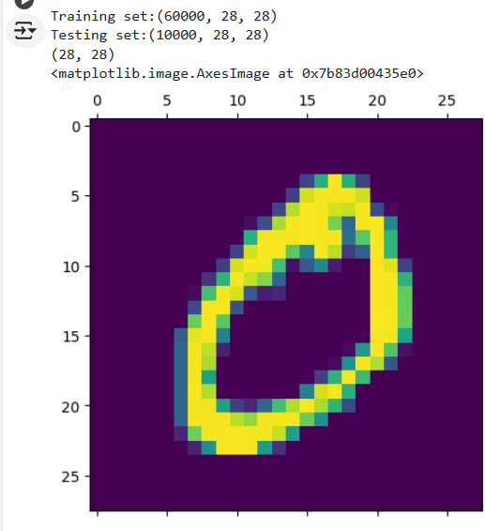

**Step4:TrainaModel**

#Normalizingthedataset x_train=X_train/255 x_test=X_test/255

#Flattingthedatasetinordertocomputeformodelbuilding x_train_flatten=x_train.reshape(len(x_train),28*28) x_test_flatten=x_test.reshape(len(x_test),28*28) x_train_flatten.shape

**Step5:Make Predictions**

Usethemodeltomakepredictionsbasedontheindependentvariable.

model=keras.Sequential([

keras.layers.Dense(10,input_shape=(784,),

activation='sigmoid')

])

model.compile(

optimizer='adam',

loss='sparse_categorical_crossentropy', metrics=['accuracy'])

model.fit(x_train_flatten,y_train,epochs=5

)

# OUTPUT:

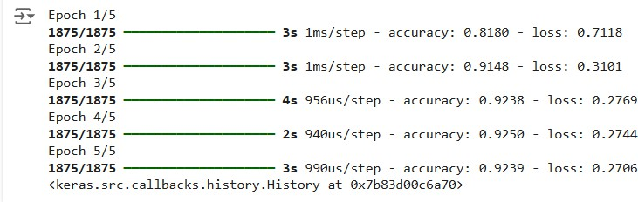

**Step6:EvaluatetheModel**

Evaluatethemodelperformance.

model.evaluate(x_test_flatten,y_test)

# OUTPUT:



**RESULT:**

Thisstep-by-stepprocesswillhelpustoimplementSingleLayerPerceptronmodels using the Keras dataset and analyze their performance.

**EXPT NO : 5 ApythonprogramtoimplementMultiLayer DATE: 20.09.2024 Perceptron With Backpropagation**

# AIM:

TowriteapythonprogramtoimplementMultilayerperceptronwith backpropagation .

# PROCEDURE:

ImplementingMultilayerperceptronwithbackpropagationusingtheKerasdataset involve the following steps:

**Step1:ImportNecessaryLibraries**

First,importthelibrariesthatareessentialfordatamanipulation,visualization,and model building.

# importing modules

importtensorflowastf import numpy as np

fromtensorflow.keras.modelsimportSequential from tensorflow.keras.layers import Flatten

from tensorflow.keras.layers import Dense

fromtensorflow.keras.layersimportActivation import matplotlib.pyplot as plt

**Step2:LoadtheKerasDataset**

TheKerasdatasetcanbeloaded.

(x_train, y_train), (x_test, y_test) = tf.keras.datasets.mnist.load_data()

# OUTPUT:



**Step3:DataPreprocessing**

Ensurethedataiscleanandreadyformodeling.SincetheIrisdatasetisclean, minimal preprocessing is needed.

#Casttherecordsintofloatvalues x_train = x_train.astype('float32') x_test = x_test.astype('float32')

#normalizeimagepixelvaluesbydividing # by 255

gray_scale = 255 x_train/=gray_scale x_test /= gray_scale

print("Featurematrix:",x_train.shape) print("Target matrix:", x_test.shape)

print("Featurematrix:",y_train.shape) print("Target matrix:", y_test.shape)

# OUTPUT:

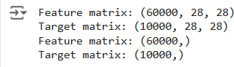

**Step4:TrainaModel**

model = Sequential([

#reshape28row*28columndatato28*28rows Flatten(input_shape=(28, 28)),

# dense layer 1

Dense(256, activation='sigmoid'),

# dense layer 2

Dense(128, activation='sigmoid'),

# output layer

Dense(10, activation='sigmoid'),

**])**

# OUTPUT:



**Step5:Make Predictions**

Usethemodeltomakepredictionsbasedontheindependentvariable.

model.compile(optimizer='adam',

loss='sparse_categorical_crossentropy',

metrics=['accuracy']) model.fit(x_train,y_train,epochs=10,

batch_size=2000,

validation_split=0.2)

# OUTPUT:

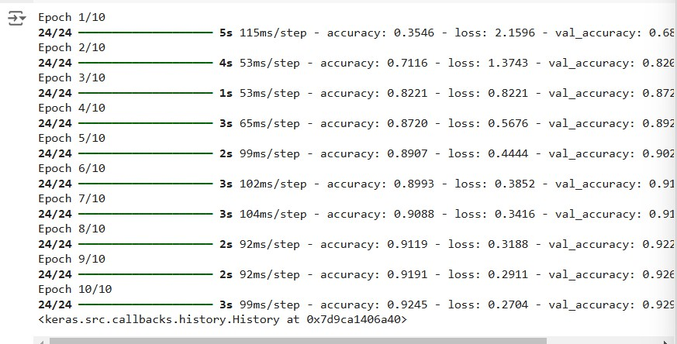

**Step6:EvaluatetheModel**

Evaluatethemodelperformance.

results=model.evaluate(x_test,y_test,verbose=0) print('test loss, test acc:', results)

fig,ax=plt.subplots(10,10) k = 0

for i in range(10):

for j in range(10): ax[i][j].imshow(x_train[k].reshape(28,28),

aspect='auto')

k += 1

plt.show()

# OUTPUT:



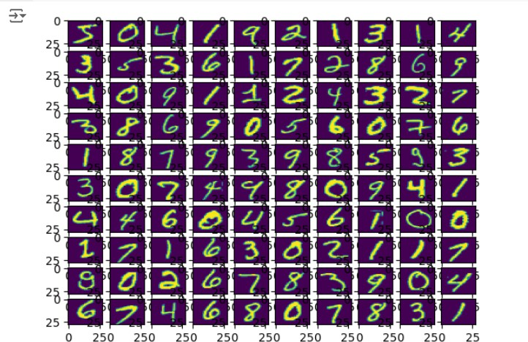

**RESULT:**

Thisstep-by-stepprocesswillhelpustoimplementMultiLayerPerceptronwith BackpropagationmodelsusingtheKerasdatasetandanalyzetheirperformance.

**EXPT NO: 6 Apythonprogramtodofacerecognitionusing DATE: 27.09.2024 SVM Classifier**

# AIM:

TowriteapythonprogramtoimplementfacerecognitionusingtheSVM Classifier

**PROCEDURE:**

ImplementingfacerecognitionusingtheSVMClassifierusingthecatanddog dataset involve the following steps:

**Step1:ImportNecessaryLibraries**

First,importthelibrariesthatareessentialfordatamanipulation,visualization,and model building.

importpandasaspd import imageio

import os

fromskimage.transformimportresize from skimage.io import imread

import numpy as np

importmatplotlib.pyplotasplt from sklearn import svm

from sklearn.model_selection import GridSearchCV

fromsklearn.model_selectionimporttrain_test_split from sklearn.metrics import accuracy_score

from sklearn.metrics import classification_report

**Step2:LoadtheDogandcatDataset**

Thedogandcatdatasetcanbeloaded.

Categories=['cats','dogs'] flat_data_arr=[]#inputarray target_arr=[] #output array datadir='/content/images'

#pathwhichcontainsallthecategoriesofimages for i in Categories:

print(f'loading...category:{i}') path=os.path.join(datadir,i)

for img in os.listdir(path): img_array=imread(os.path.join(path,img)) img_resized=resize(img_array,(150,150,3)) flat_data_arr.append(img_resized.flatten()) target_arr.append(Categories.index(i))

print(f'loadedcategory:{i}successfully') flat_data=np.array(flat_data_arr) target=np.array(target_arr)

#dataframe df=pd.DataFrame(flat_data) df['Target']=target df.shape

# OUTPUT:



**Step3:Separateinputfeaturesandtargets.**

#input data x=df.iloc[:,:-1] #output data y=df.iloc[:,-1]

**Step4:Separatetheinputfeaturesandtarget**

# Splitting the data into training and testing sets x_train,x_test,y_train,y_test=train_test_split(x,y,test_size=0.20, random_state=77, stratify=y)

**Step5:Buildandtrainthemodel**

#DefiningtheparametersgridforGridSearchCV param_grid={'C':[0.1,1,10,100],

'gamma':[0.0001,0.001,0.1,1],

'kernel':['rbf','poly']}

#Creatingasupportvectorclassifier svc=svm.SVC(probability=True)

#CreatingamodelusingGridSearchCVwiththeparametersgrid model=GridSearchCV(svc,param_grid)

#Trainingthemodelusingthetrainingdata model.fit(x_train,y_train)

# OUTPUT:

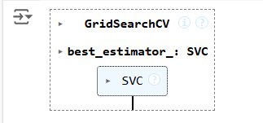

**Step6:Model evaluation**

#Testingthemodelusingthetestingdata y_pred = model.predict(x_test)

# Calculating the accuracy of the model accuracy=accuracy_score(y_pred,y_test)

# Print the accuracy of the model

print(f"The model is {accuracy*100}% accurate")

print(classification_report(y_test, y_pred, target_names=['cat', 'dog']))

# OUTPUT:

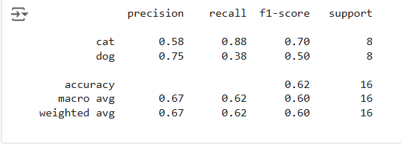

**Step7: Prediction**

path='/content/cat.83.jpg'img=imread(path) plt.imshow(img)

plt.show() img_resize=resize(img,(150,150,3)) l=[img_resize.flatten()] probability=model.predict_proba(l)

for ind,val in enumerate(Categories):

print(f'{val}= {probability[0][ind]*100}%')

print("The predicted image is : "+Categories[model.predict(l)[0]])

# OUTPUT:

cats = 52.70216647851706%

dogs = 47.29783352148294%

The predicted image is : cat

# RESULT:

ThustheprocesshelpsustoimplementthefacerecognitionusingSVMClassifier using python program.

# EX.NO: 8 APYTHONPROGRAMTOIMPLEMENT DATE : 18.10.2024 ADA BOOSTING

**AIM:**

TowriteapythonprogramtoimplementADABoosting.

# PROCEDURE:

ImplementingADABoostingusingthedatasetinvolvethefollowingsteps:

**Step1:ImportNecessaryLibraries**

First,importthelibrariesthatareessentialfordatamanipulation,visualization,and model building.

import numpy as np importpandasaspd

from sklearn.tree import DecisionTreeClassifier

frommlxtend.plottingimportplot_decision_regions import seaborn as sns

from sklearn.metrics import accuracy_score

**Step2:Loadandpreparedata**

**sns.scatterplot(x=df['X1'], y=df['X2'], hue=df['label'])**

**df['weights'] = 1 / df.shape[0]**

|  |  |  |  |  |  |  |  |  |
| --- | --- | --- | --- | --- | --- | --- | --- | --- |
| **df = pd.DataFrame()** | | | | | | | | |
| **df['X1'] = [1, 2,** | **3,** | **4,** | **5,** | **6,** | **6,** | **7,** | **9,** | **9]** |
| **df['X2'] = [5, 3,** | **6,** | **8,** | **1,** | **9,** | **5,** | **8,** | **9,** | **2]** |
| **df['label'] = [1,** | **1,** | **0,** | **1,** | **0,** | **1,** | **0,** | **1,** | **0, 0]** |

x = df.iloc[:, 0:2].values

y = df.iloc[:, 2].values

# OUTPUT:

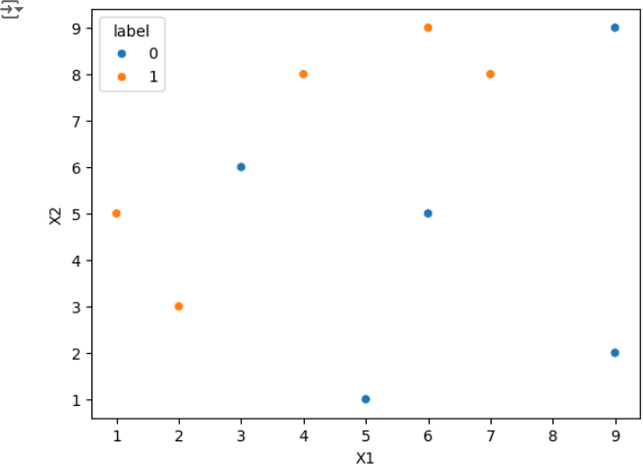

**Step3:Trainthe1stmodel**

# Step 2: Train 1st Model

dt1=DecisionTreeClassifier(max_depth=1) dt1.fit(x, y)

plot_decision_regions(x,y,clf=dt1,legend=2) df['y_pred'] = dt1.predict(x)

# OUTPUT:

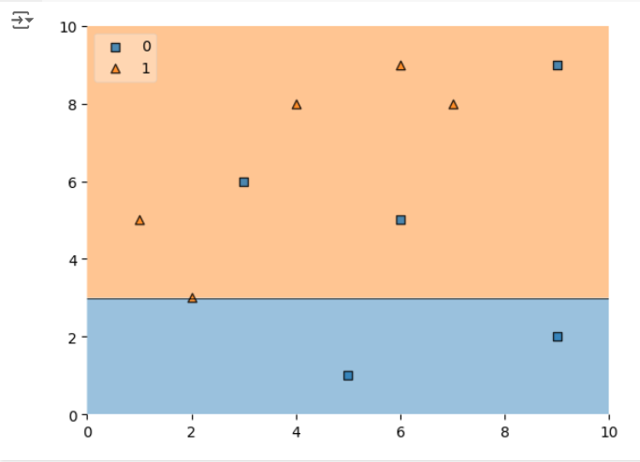

**Step4:Calculatemodelweight**

# Step 4: Update Weights

defupdate_row_weights(row,alpha=0.423): if row['label'] == row['y_pred']:

returnrow['weights']*np.exp(-alpha) else:

return row['weights'] * np.exp(alpha)

df['updated_weights']= df.apply(update_row_weights, axis=1)

df['normalized_weights']=df['updated_weights']/ df['updated_weights'].sum()

df['cumsum_upper'] = np.cumsum(df['normalized_weights'])

df['cumsum_lower'] = df['cumsum_upper'] - df['normalized_weights']

**Step5:Createnewdataset**

# Step 5: Create New Dataset

defcreate_new_dataset(df): indices = []

foriinrange(df.shape[0]): a = np.random.random()

for index, row in df.iterrows():

ifrow['cumsum_upper']>aanda>row['cumsum_lower']: indices.append(index)

return indices

index_values = create_new_dataset(df)

second_df = df.iloc[index_values, [0, 1, 2, 3]]

**Step6:Train2ndmodel**

# Step 6: Train 2nd Model

dt2=DecisionTreeClassifier(max_depth=1) x = second_df.iloc[:, 0:2].values

y = second_df.iloc[:, 2].values

dt2.fit(x, y)

# OUTPUT:

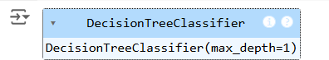

**Step7:Plotdecisiontreeandcalculatemodelweightsfor2ndmodel**

# Plot the decision tree for the second model plot_decision_regions(x,y,clf=dt2,legend=2) second_df['y_pred'] = dt2.predict(x)

#Step7:CalculateModelWeightfor2ndModel alpha2 = calculate_model_weight(0.1)

print(f"Alpha2: {alpha2}")

**Step8:updateweightsfor2ndmodel**

# Step 8: Update Weights for 2nd Model

defupdate_row_weights(row,alpha=1.09): if row['label'] == row['y_pred']:

returnrow['weights']*np.exp(-alpha) else:

return row['weights'] * np.exp(alpha)

second_df['updated_weights']= second_df.apply(update_row_weights, axis=1)

second_df['nomalized_weights']=second_df['updated_weights']/ second_df['updated_weights'].sum()

second_df['cumsum_upper'] = np.cumsum(second_df['nomalized_weights'])

second_df['cumsum_lower']=second_df['cumsum_upper']- second_df['nomalized_weights']

**Step9:Calculatealphafor3rdmodel**

#Step9:CalculateAlphafor3rdModel alpha3 = calculate_model_weight(0.7)

print(f"Alpha3: {alpha3}")

# Step 10: Accuracy Calculation y_true = second_df['label'].values y_pred=second_df['y_pred'].values

#CalculateaccuracyfortheAdaBoostmodel accuracy = accuracy_score(y_true, y_pred)

print(f"Accuracy of the AdaBoost model: {accuracy:.4f}")

# OUTPUT:

**ALPHA3:-0.4236489301936017**

**AccuracyoftheAdaBoostingmodel:0.80000**

# RESULT:

ThusthepythonprogramtoimplementAdaboostinghasbeenexecuted successfully and the results have been verified.

**EXPT NO: 9A Apythonprogramtoimplement DATE: 25.10.2024 KNN MODEL .**

# AIM:

TowriteapythonprogramtoimplementKNNModel.

# PROCEDURE:

ImplementingKNNModelusingthemall_customerdatasetinvolvethefollowing steps:

**Step1:ImportNecessaryLibraries**

First,importthelibrariesthatareessentialfordatamanipulation,visualization,and model building.

import numpy as np

importmatplotlib.pyplotasplt import pandas as pd

fromsklearn.model_selectionimporttrain_test_split from sklearn.preprocessing import StandardScaler

from sklearn.neighbors import KNeighborsClassifier

fromsklearn.metricsimportclassification_report,confusion_matrix from sklearn.cluster import KMeans

**Step2:LoadtheDataset**

Themall_customerdatasetcanbeloadedanddisplaythefirstfewrowsofthedataset.

# Load the dataset

dataset = pd.read_csv('/content/Mall_Customers.csv')

#Displaythefirstfewrowsofthedataset print(dataset.head())

# Display the dimensions of the dataset print(f"Datasetshape:{dataset.shape}")

#Displaydescriptivestatisticsofthedataset print(dataset.describe())

**Step3:Separatethefeatures(x)andtargetvariable (y)**

# Separate the features (X) and the target variable (y)

X = dataset.iloc[:, [3, 4]].values #Weuse'AnnualIncome'and'Spending Score'

#Standardizethefeatures scaler = StandardScaler()

X_scaled = scaler.fit_transform(X)

**Step4:Visualizingtheclusterofcustomer**

#ApplyKMeansclusteringusingtheElbowMethodtofindtheoptimalnumber of clusters

wcss = [] #Within-clustersumofsquares for i in range(1, 11):

kmeans=KMeans(n_clusters=i,init='k-means++',max_iter=300,n_init=10, random_state=0)

|  |  |  |  |  |  |  |  |  |
| --- | --- | --- | --- | --- | --- | --- | --- | --- |
| **kmeans.fit(X_scaled) wcss.append(kmeans.inertia_)**  **# Plot the Elbow Method graph plt.plot(range(1, 11), wcss) plt.title('The Elbow Method') plt.xlabel('Numberofclusters') plt.ylabel('WCSS')**  **plt.show()**  **#Fromtheplot,wecanobservethattheoptimalnumberofclustersis5 (elbow point)**  **kmeans=KMeans(n_clusters=5,init='k-means++',max_iter=300,n_init=10, random_state=0)**  **y_kmeans = kmeans.fit_predict(X_scaled)**  **# Visualizing the clusters of customers** | | | | | | | | |
| **plt.scatter(X_scaled[y_kmeans c='red', label='Cluster 1')** | **==** | **0,** | **0],** | **X_scaled[y_kmeans** | **==** | **0,** | **1],** | **s=100,** |
| **plt.scatter(X_scaled[y_kmeans c='blue', label='Cluster 2')** | **==** | **1,** | **0],** | **X_scaled[y_kmeans** | **==** | **1,** | **1],** | **s=100,** |
| **plt.scatter(X_scaled[y_kmeans c='green', label='Cluster 3')** | **==** | **2,** | **0],** | **X_scaled[y_kmeans** | **==** | **2,** | **1],** | **s=100,** |
| **plt.scatter(X_scaled[y_kmeans c='cyan', label='Cluster 4')** | **==** | **3,** | **0],** | **X_scaled[y_kmeans** | **==** | **3,** | **1],** | **s=100,** |
| **plt.scatter(X_scaled[y_kmeans** | **==** | **4,** | **0],** | **X_scaled[y_kmeans** | **==** | **4,** | **1],** | **s=100,** |
| **c='magenta', label='Cluster 5')** | | | | | | | | |

# Plot the centroids

plt.scatter(kmeans.cluster_centers_[:,0],kmeans.cluster_centers_[:,1], s=300, c='yellow', label='Centroids')

plt.title('Clusters of customers') plt.xlabel('Annual Income (k$)') plt.ylabel('SpendingScore(1-100)') plt.legend()

plt.show()

# OUTPUT:

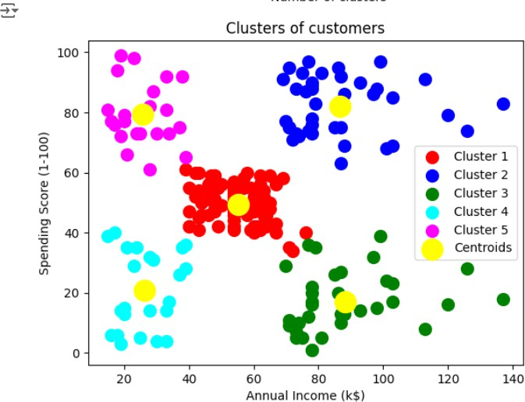

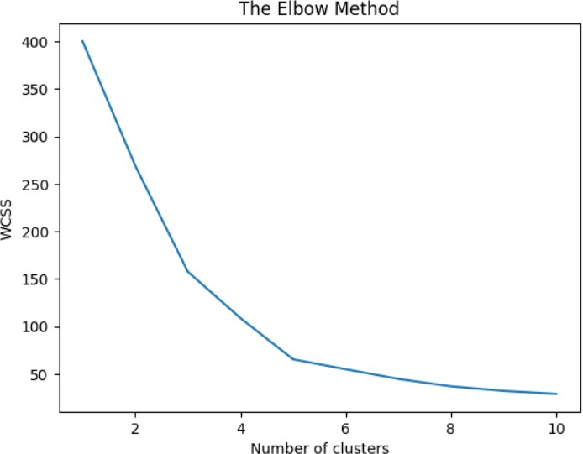

**RESULT:**

ThusthepythonprogramtoimplementKNNmodelhasbeensuccessfully implemented and the results have been verified.

**EXPT NO: 9B Apythonprogramtoimplement DATE: 25.10.2024 K-Means Model**

# AIM:

TowriteapythonprogramtoimplementtheK-meansModel.

# PROCEDURE:

ImplementingK-meansModelusingthemall_customerdatasetinvolvethe following steps:

**Step1:ImportNecessaryLibraries**

First,importthelibrariesthatareessentialfordatamanipulation,visualization,and model building.

import numpy as np importpandasaspd

from math import sqrt

**Step2:loadthe Dataset**

data = pd.read_csv('/content/Mall_Customers.csv')

data.head(5)

# OUTPUT:

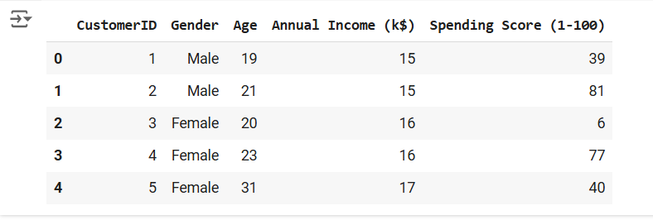

**Step3:Preprocessthedata**

req_data = data[['Age', 'Annual Income (k$)', 'Spending Score (1-100)']]

req_data.head(5)

# OUTPUT:

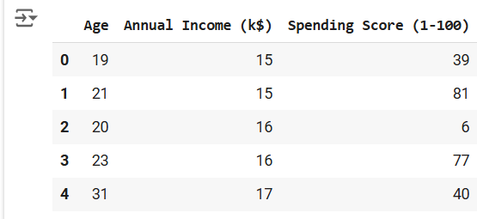

**Step4:Assignthedatapointstoclusters**

shuffle_index = np.random.permutation(req_data.shape[0]) #Shufflethe dataset rows

req_data = req_data.iloc[shuffle_index]

req_data.head(5)

# OUTPUT:

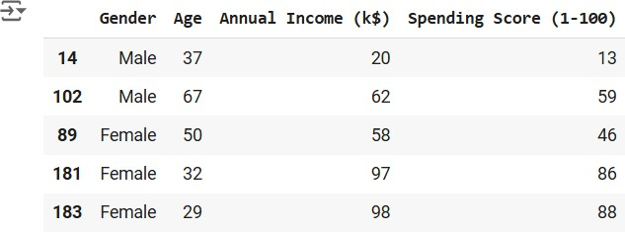

**Step5:Updatetheclusterscenters**

train_size = int(req_data.shape[0]*0.7) #Set70%ofthedatafortraining train_df = req_data.iloc[:train_size,:]

test_df = req_data.iloc[train_size:,:]

train = train_df.values #Converttraindatatonumpyarray test = test_df.values # Convert test data to numpy array y_true = test[:,-1] # The target values for the test set

print('Train_Shape:',train_df.shape) print('Test_Shape: ', test_df.shape)

from math import sqrt

defeuclidean_distance(x_test,x_train): distance = 0

for i in range(len(x_test)): #Loopthroughallfeatures distance += (x_test[i]-x_train[i])**2

return sqrt(distance)

defget_neighbors(x_test,x_train,num_neighbors): distances = []

data = []

for i in x_train: distances.append(euclidean_distance(x_test,i)) data.append(i)

distances = np.array(distances)

data = np.array(data)

sort_indexes = distances.argsort() #Sortdistancesinascendingorder data = data[sort_indexes] # Sort the data based on sorted distances

return data[:num_neighbors] #Returntheclosest'num_neighbors'neighbors

defprediction(x_test,x_train,num_neighbors): classes = []

neighbors=get_neighbors(x_test,x_train,num_neighbors) for i in neighbors:

classes.append(i[-1]) #The target value is the last column

predicted = max(classes, key=classes.count) #Returnthemostfrequent class (the majority vote)

return predicted

defpredict_classifier(x_test): classes = []

neighbors = get_neighbors(x_test, req_data.values, 5) #Predictusing the top 5 neighbors

for i in neighbors: classes.append(i[-1])

predicted = max(classes, key=classes.count) #Returnthemajorityvote print(predicted)

return predicted

defaccuracy(y_true,y_pred): num_correct = 0

for i in range(len(y_true)):

if y_true[i] == y_pred[i]: #Comparetruevaluestopredictedvalues num_correct += 1

accuracy = num_correct / len(y_true) #Calculateaccuracyastheratio of correct predictions

return accuracy

defaccuracy(y_true,y_pred): num_correct = 0

for i in range(len(y_true)):

ify_true[i]==y_pred[i]: num_correct += 1

returnnum_correct/len(y_true) y_pred = []

for i in test:

y_pred.append(prediction(i, train, 5)) #Makepredictionsforeachtest instance

#Calculateandprinttheaccuracy acc = accuracy(y_true, y_pred)

print(f"Accuracy: {acc * 1000:.2f}%")

# OUTPUT:



**RESULT:**

Thusthepythonprogramimplementingthek-meansmodelissuccessful.

**EXPT NO: 10 ApythonprogramtoimplementDimensionality DATE: 04.11.2024 Reduction -PCA.**

# AIM:

TowriteapythonprogramtoimplementDimensionalityReduction-PCA.

# PROCEDURE:

ImplementingDimensionalityreduction-pcausingtheIrisdatasetinvolvethe following steps:

**Step1:ImportNecessaryLibraries**

First,importthelibrariesthatareessentialfordatamanipulation,visualization,and model building.

#Importingnecessarylibraries from sklearn import datasets

import pandas as pd

fromsklearn.preprocessingimportStandardScaler from sklearn.decomposition import PCA

import seaborn as sns

import matplotlib.pyplot as plt

**Step2:LoadtheIrisDataset**

TheIrisdatasetcanbeloadedanddisplaythefirstfewrowsofthedataset

# Load the Iris dataset iris=datasets.load_iris()

df = pd.DataFrame(iris['data'], columns=iris['feature_names'])

# Display the first few rows of the dataset

df.head()

# OUTPUT:

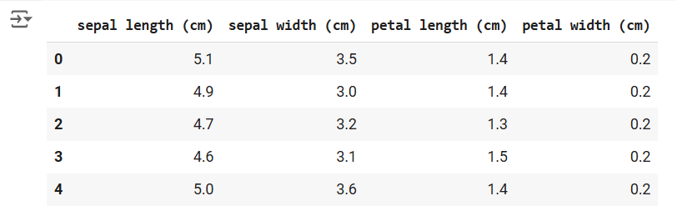

**Step3:Standardizethe data**

#StandardizethefeaturesusingStandardScaler scalar = StandardScaler()

scaled_data = pd.DataFrame(scalar.fit_transform(df)) #Scaling the data

#Displaythescaleddata(optional) scaled_data.head()

# OUTPUT:

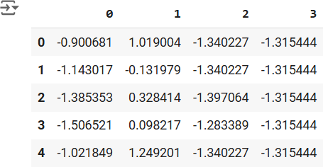

**Step4:ApplyPCA**

#ApplyPCAtoreducethedatato3components pca = PCA(n_components=3)

pca.fit(scaled_data) #Fit PCA on scaled data

data_pca = pca.transform(scaled_data) #Transformthedatatoprincipal components

# Convert PCA data to a DataFrame for easier inspection

data_pca=pd.DataFrame(data_pca,columns=['PC1','PC2','PC3']) data_pca.head()

# OUTPUT:

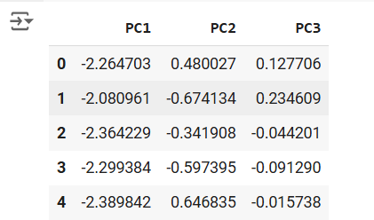

**Step5:ExplainedVarianceRatio**

#Calculatetheexplainedvarianceratioforeachprincipalcomponent explained_variance = pca.explained_variance_ratio_

print(f"ExplainedVariance Ratio: {explained_variance}")

# This output shows how much variance each principal component explains.

# OUTPUT:



**Step6:Visualizethereduceddata.**

#Plottingtheexplainedvarianceratioasascreeplot plt.figure(figsize=(8, 5))

plt.bar(range(1,len(explained_variance)+1),explained_variance,alpha=0.7, color='blue')

plt.ylabel('ExplainedVarianceRatio') plt.xlabel('Principal Components') plt.title('Scree Plot')

plt.show()

# OUTPUT:

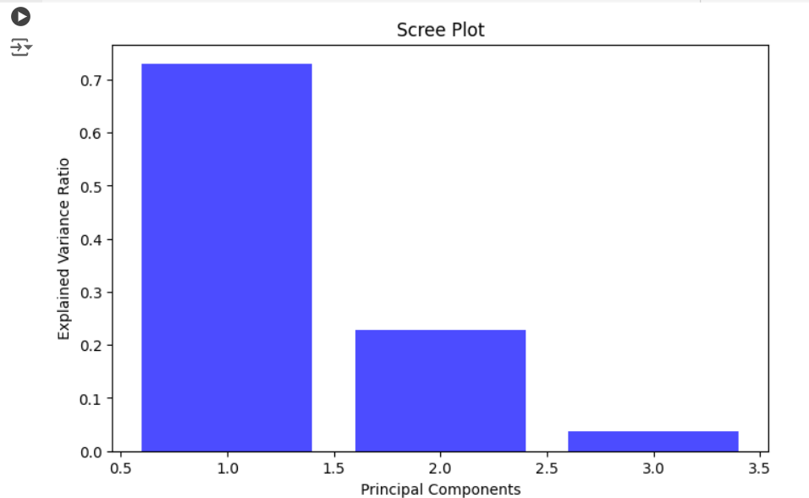

**RESULT:**

ThustheDimensionalityReductionhasbeenimplementedusingPCAinpython program Successfully.